

Credit Card Data Insights

Report

**Title**

**“**Credit Card Analysis” for Usage and Performance Across Different Card Categories

**Objective**

* This project aims to analyse **credit card usage trends and performance metrics** across different card categories (e.g., Blue, Silver, Gold, Platinum).
* It helps businesses understand **which card types generate the most profit, which have the highest customer base, and how different cards are used.**

**Data Source & Preparation**

* **Data Source:** The dataset was provided by the professor in CSV format.
* **Removed Duplicates:** Eliminated duplicate transactions for accuracy.
* **Handled Missing Values:** Removed rows with excessive missing values**.**
* **Standardized Text Formats:** Unified card category names and cleaned extra spaces.
* **Corrected Data Types:** Converted amounts, dates, and interest rates to the correct formats.
* **Created New Columns:**
* Exceed_Credit_Limit – Flags transactions exceeding the credit limit.
* Profit – Calculated as Revenue - Customer Acquisition Cost (CAC).

**Dashboard Overview**

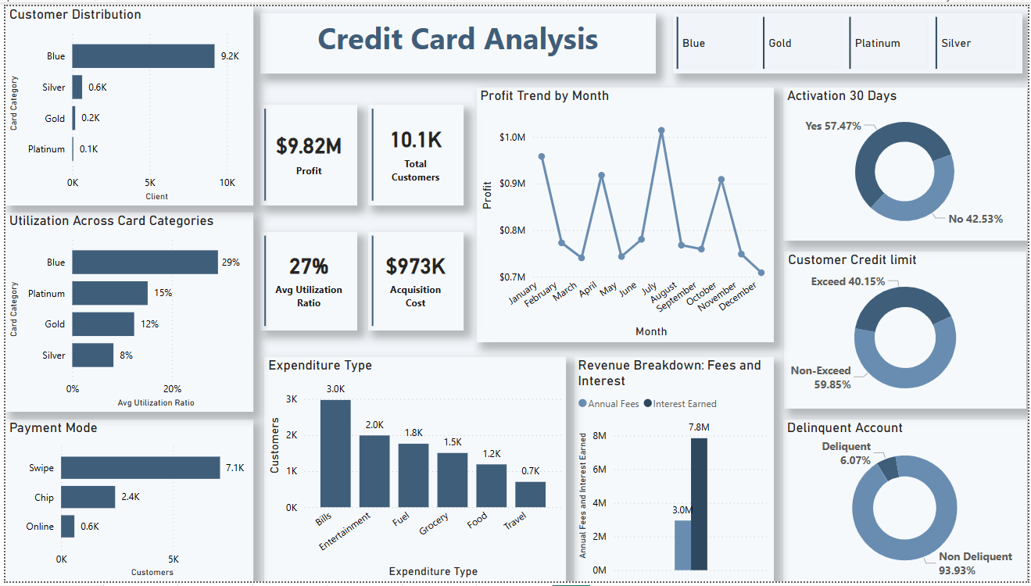

The dashboard includes key KPIs such as Profit ($9.82M), Total Customers (10.1K), Average Utilization Ratio (27%), and Acquisition Cost ($973K). These metrics provide insights into the financial performance, customer base, and credit utilization trends.

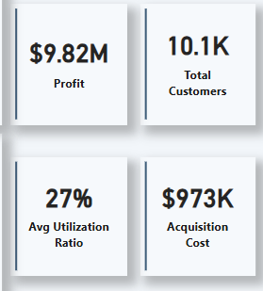

**Key Visualizations:**

* + **Customer Distribution by Card Category** – Shows the number of customers using each card type (Blue, Silver, Gold, Platinum).
  + **Utilization Across Card Categories** – Displays the average utilization ratio for each card type.
  + **Payment Mode** – Analyses transactions by payment method (Swipe, Chip, Online).
  + **Profit Trend by Month** – Tracks how profit fluctuates monthly.
  + **30-Day Activation Rate** – Measures the percentage of new customers who use their card within the first 30 days.
  + **Customer Credit Limit** – Shows the percentage of customers exceeding or staying within their credit limit.
  + **Expenditure Type** – Highlights where customers spend the most (Bills, Entertainment, Fuel, Grocery, Food, Travel).
  + **Revenue Breakdown** – Represents the structure of revenue, showing different sources such as interest earned and annual fees.
  + **Delinquent Accounts** – Identifies the percentage of customers who are delinquent on payments.

**Interactivity Features**

* Filters for different **card categories** (Blue, Gold, Platinum, Silver).
* The **Profit Trend by Month** visualization acts as a **month slicer**, allowing users to filter data based on a selected month.
* **Each visualization works as a filter**, so clicking on any category, payment mode, or expenditure type dynamically updates other charts.

**Blue Card Selected**

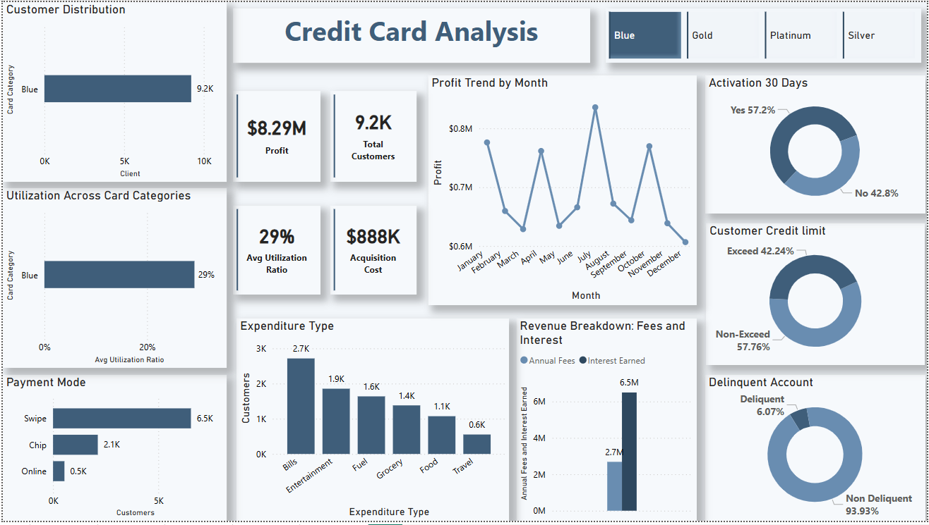

* When the **Blue** card category is selected, all visuals update dynamically to display insights specific to **Blue card users**. This includes:
  + Customer distribution
  + Utilization ratio
  + Payment modes
  + Expenditure types
  + Profit trends
  + Revenue breakdown
  + Activation rates
  + Delinquency status
* Similarly, selecting **Gold, Platinum, or Silver** filters the dashboard to show data for the respective card category, allowing for a detailed comparison of different card types.

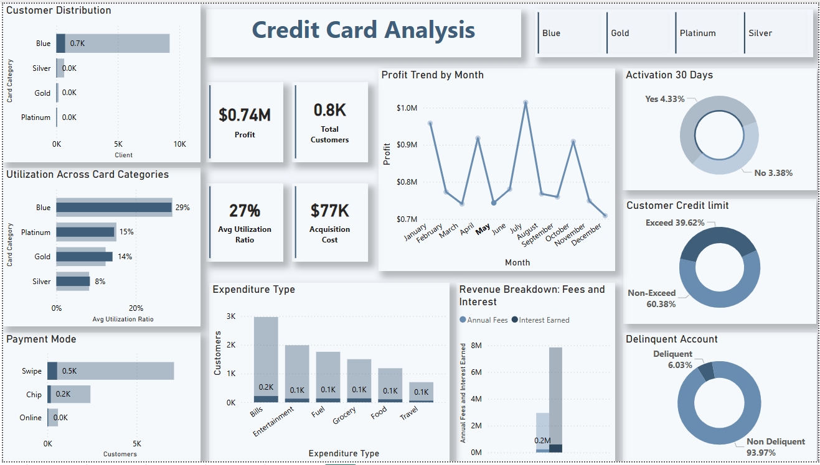

* Selecting a specific **month** from the **Profit Trend by Month** chart updates all visuals to display data only for that selected month.
* This allows for a **time-based analysis**, helping to identify trends in profit, customer activity, expenditure, and delinquency rates over different months.
* This feature works alongside the **card category filters**, enabling a more granular analysis of credit card usage and performance over time.

**Derived Metrics & Calculated Fields:**

* This formula helps identify customers who have transacted an amount exceeding their credit limit.

**Exceed_credit_limit** = IF(credit_card[Total_Trans_Amt] > credit_card[Credit_Limit],"Exceed", "Non-Exceed")

* This formula calculates the amount the user has paid

**Credit_Amount_Paid** = credit_card[Total_Trans_Amt]-credit_card[Total_Revolving_Bal]

* Percentage of amount that the user has paid

**Total_Paid_Pct** = (credit_card[Credit_Amount_Paid])/credit_card[Total_Trans_Amt]

* Extracts the current year from the transaction date for time-based analysis.

**Year** = YEAR (credit_card[Week_Start_Date])

**Measures:**

* **Active Customers count**

Active_Customers =CALCULATE(COUNT(credit_card[Activation_30_Days]),credit_card[Activation_30_Days]=1)

* **Profit**

Profit = CALCULATE((SUM(credit_card[Annual_Fees]) + SUM(credit_card[Interest_Earned]))-SUM(credit_card[Customer_Acq_Cost]))

* **Revenue**

Revenue = CALCULATE(SUM(credit_card[Annual_Fees]) + SUM(credit_card[Interest_Earned]))

**Key Insights**

* **Customer Base:** The Blue card dominates in user count (91%), but Platinum and Gold customers contribute more to revenue.
* **Card Utilization:** Blue cardholders have the highest utilization rate, while Platinum users spend more per transaction.
* **Expenditure Patterns:**
  1. **(overall):** Bills and entertainment are the top spending categories, while travel and food have the lowest spending.
  2. **By Card Category:**
* **Blue & Silver Cards:** Bills and entertainment have the highest spending.
* **Gold Card:** Bills and travel are the top spending categories.

**Platinum Card:** Travel and bills have the highest spending.

* **Payment Mode Trends:** Swipe transactions are the most common across all card types, while online payments are the least used.
* **Credit Limits:** 40% of customers exceed their credit limits, with Blue and Platinum cardholders being the most affected.
* **Activation Challenges:** A low percentage of new customers activate their cards within 30 days.
* **Delinquency Rate:** Higher-tier cards (Gold & Platinum) have lower delinquency rates, while lower-tier cards (Blue & Silver) have more late payments.

**Decision Making Impact**

* **Targeting High-Value Customers:** Focus on Platinum & Gold users for higher revenue.
* **Managing Credit Risk:** Adjust limits as 40% exceed them, mainly Blue & Platinum users.
* **Optimizing Spending Incentives:** Align rewards with top spending areas (bills, entertainment, travel).
* **Enhancing Payment Methods:** Promote online payments since swipe dominates.
* **Boosting Activation Rates:** Improve onboarding to increase early card usage.
* **Reducing Delinquency:** Strengthen monitoring for lower-tier cards with higher late payments

**Challenges & Solutions**

* **Missing or Duplicate Data** → Cleaned and standardized data for accurate analysis.
* **Incorrect Data Types** → Changed column formats (e.g., date, number, text) for accurate calculations.
* **DAX Formula Issues** → Refined calculated fields to ensure correct metrics (e.g., profit calculation, exceeding credit limit).
* **Visual Formatting** → Adjusted charts and labels for clear and consistent presentation.
* **Filter & Interactivity Challenges** → Ensured all visuals update dynamically based on selections.

**Conclusion**

This project provided valuable insights into **credit card usage, customer spending behaviour, and financial performance** across different card categories. The analysis helped identify key trends, such as **high utilization rates, spending patterns, credit limit exceedance, and delinquency risks**. The interactive dashboard enabled **easy data exploration** for better decision-making.

**Future Improvements**

* Real-Time Data Updates to provide up-to-date insights.
* Deeper Customer Segmentation to personalize offers and rewards.
* Predictive Analytics to forecast spending trends and credit risks.
* More Detailed Revenue Breakdown to analyse profit sources more effectively.
* Enhanced Credit Utilization Analysis to understand spending patterns better.
* Customer Retention Insights by analysing long-term engagement trends.
* Comparative Analysis Over Time to track performance across different periods.